**ABSTRACT**

**Heart Disease Prediction through Exploratory Data Analysis**

Heart disease remains one of the leading causes of mortality worldwide, making its early prediction a critical aspect of preventive healthcare. This study employs Exploratory Data Analysis (EDA) to uncover patterns, trends, and relationships in clinical datasets to enhance the prediction of heart disease. By analyzing key features such as age, cholesterol levels, blood pressure, and lifestyle habits, EDA offers a comprehensive understanding of the underlying data and its impact on heart disease diagnosis.

The research begins with detailed data preprocessing, including handling missing values, outlier detection, and encoding categorical variables. Visualization techniques such as histograms, box plots, and correlation heatmaps are used to identify significant features and relationships. Statistical methods, including hypothesis testing and correlation analysis, further validate these findings. Feature engineering, such as grouping age ranges and normalizing continuous variables, enhances the dataset's quality and predictive capability.

The results of EDA highlight critical predictors of heart disease, including cholesterol levels, age, and resting blood pressure, and reveal patterns such as gender-based risk disparities. This analysis provides actionable insights for healthcare practitioners, facilitating early interventions and risk stratification. Moreover, the study establishes a robust foundation for predictive modeling by selecting the most impactful features.

In conclusion, EDA proves to be a powerful tool in the initial stages of heart disease prediction, enabling data-driven decision-making and supporting the development of effective machine-learning models. This approach emphasizes the importance of understanding data before embarking on predictive analytics in healthcare.

**INTRODUCTION ABOUT THE PROBLEM**

Heart disease is a significant global health issue that impacts millions of lives annually and places a considerable burden on healthcare systems worldwide. Despite advancements in medical science and public health initiatives, cardiovascular diseases (CVDs) remain the leading cause of death globally. According to the World Health Organization (WHO), heart disease accounts for approximately 32% of all deaths globally, with an estimated 17.9 million lives lost each year. This issue highlights the critical need for targeted interventions and improved healthcare strategies to combat its prevalence.

The burden of heart disease arises from various factors across multiple levels, including genetic predisposition, lifestyle choices, healthcare disparities, and socio-economic conditions. In low- and middle-income countries, limited access to preventive healthcare, diagnostic facilities, and treatment options exacerbates the impact of heart disease. Conversely, in high-income countries, lifestyle factors such as unhealthy diets, sedentary behavior, smoking, and stress contribute significantly to the prevalence of cardiovascular conditions. Additionally, risk factors like hypertension, diabetes, and high cholesterol amplify the likelihood of developing heart disease.

Addressing heart disease is crucial for achieving sustainable development goals (SDGs), particularly SDG 3 (Good Health and Well-being). By leveraging data-driven approaches and focusing on prevention, early detection, and better management of heart disease, we can reduce mortality rates, alleviate healthcare burdens, and improve overall public health outcomes. These efforts also align with the broader goals of promoting equitable access to healthcare and fostering a healthier global population.

**SYSTEM ANALYSIS**

**Feasibility Study:**

The feasibility study indicates that the project is technically viable using advanced data analytics and statistical techniques, economically beneficial by potentially reducing healthcare costs, and operationally scalable with partnerships in the medical and research community. Socially, it aligns with increasing awareness of cardiovascular health, and legal and ethical factors, along with environmental considerations, support its implementation. Overall, the project is practical and holds significant potential to improve public health outcomes.

**Technical Feasibility**

Objective: Assess whether the project can be implemented from a technical perspective.

* Data Availability: Historical and current datasets on heart disease, including clinical trials, hospital records, and open data repositories (e.g., UCI Heart Disease dataset, Framingham Heart Study), are available.
* Technology Stack: The required infrastructure is accessible, including data processing tools (e.g., Python, R) and visualization platforms (e.g., Tableau, Power BI).
* Expertise: The project requires skills in data science, statistical analysis, and domain knowledge in cardiology.

**Economical Feasibility**

* Cost of Data Acquisition: Free datasets are accessible through public repositories; additional data can be acquired via collaborations with hospitals and research organizations.
* Technology and Infrastructure Costs: Open-source libraries (e.g., TensorFlow, Pandas) and free tools like Google Colab minimize software and computational expenses.
* Operational Costs: Analytical tasks can be carried out using an internal team of data analysts and medical consultants, supplemented by external collaborations if needed.
* Return on Investment (ROI): Insights from EDA can reduce healthcare costs by early identification of high-risk groups and preventing complications.
* Scalability: The analysis framework can scale to accommodate larger datasets and integrate with predictive modeling tools with minimal additional costs.

**Operational Feasibility**

Objective: Determine whether the project can be smoothly integrated into existing operations.

* Considerations:
  + Data Integration: Evaluate the feasibility of incorporating heart disease datasets into existing healthcare IT systems or research tools.
  + Scalability: Assess whether the tools and models used for EDA can handle growing data volumes and complexity as the project expands.
  + User Acceptance: Understand the readiness of stakeholders, such as healthcare providers and public health officials, to use insights generated by the EDA in decision-making processes.

**Other Feasibility Dimensions**

* Legal and Ethical Feasibility: Compliance with healthcare data privacy regulations such as HIPAA and GDPR is essential. Implement measures to anonymize patient data and secure sensitive information during storage and analysis.
* Environmental Feasibility: Minimize the computational footprint by optimizing algorithms and leveraging energy-efficient data centers for cloud-based computations.

**DATABASE DESIGN**

**DFD:**

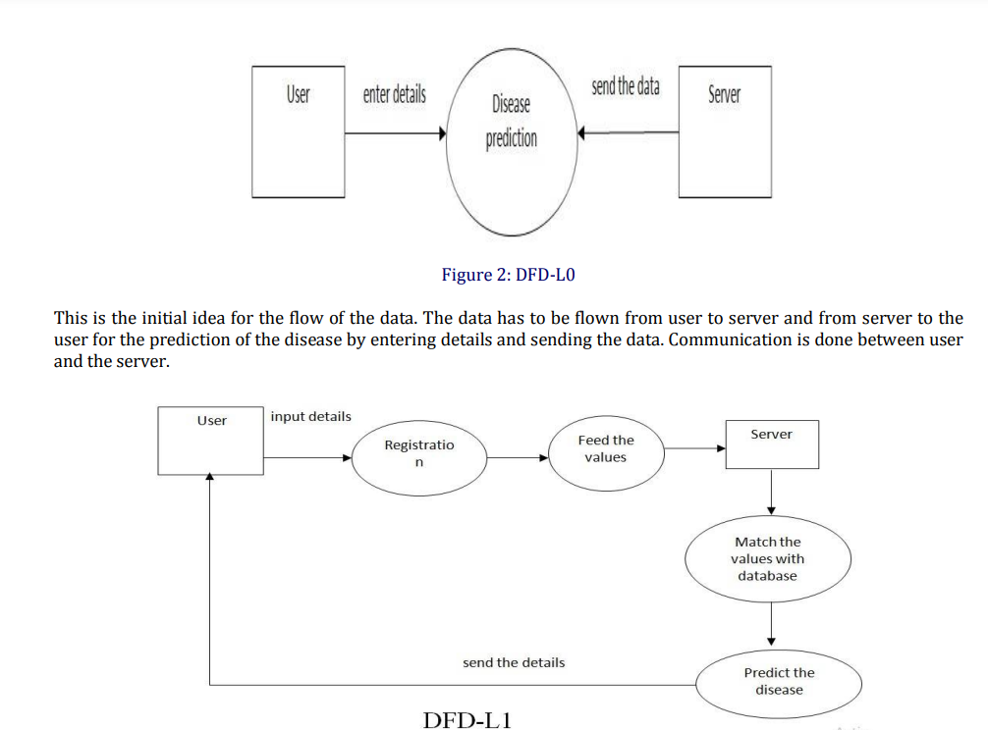

**DFD L-0**



**DFD L-1**

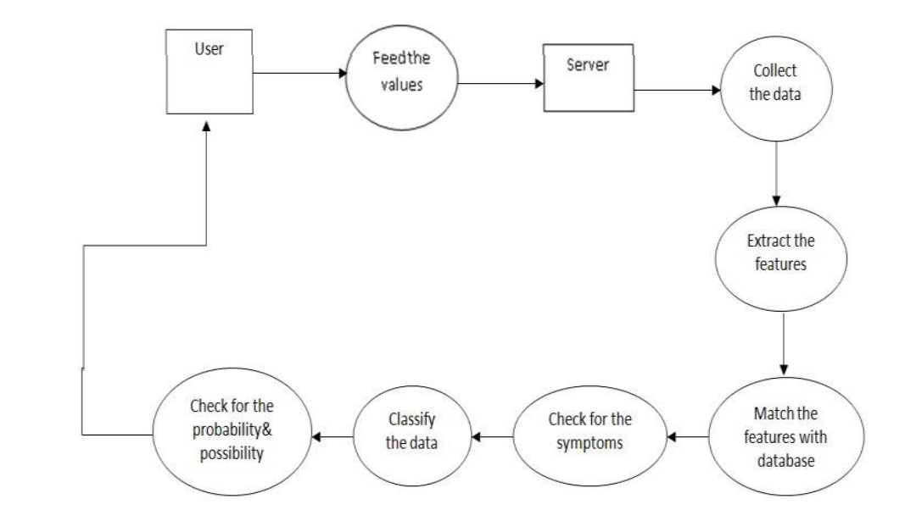

**TESTING**

**Unit Testing: -**

In unit testing, individual components or functions of your reducing food waste are tested in isolation.

- This would involve testing specific algorithms, data processing functions, or any small units of code that make up the model.

- The goal is to ensure that each unit performs as expected and produces accurate results.

**Module Testing: -**

Module testing focuses on testing groups of related units or modules that work together.

- This could involve testing different parts of your reducing food waste, such as data preprocessing, feature engineering, and model training as separate modules.

- The aim is to verify that these modules interact correctly and produce the desired outputs.

**Integration Testing: -**

Integration testing examines the interactions between different modules or components to ensure they function correctly when combined.

- This would involve testing how data flows between data preprocessing, model training, and prediction modules, ensuring seamless integration.

**System Testing: -**

System testing assesses the entire reduce food waste prediction system as a whole.

- This involves testing the end-to-end functionality of your model, from data input to generating rainfall predictions.

- You'll check if the system meets its intended goals and requirements.

**White Box Testing: -**

White box testing examines the internal logic and structure of your code.

- For your project, you'd analyze the code of your reducing food waste model to ensure it follows best practices, doesn't have any code smells, and is efficient.

- This can involve code reviews and static analysis tools.

**Black Box Testing**: -

Black box testing assesses the functionality of the system without examining its internal code.

- Testers focus on inputs and expected outputs, ensuring that the model produces accurate reduce food waste predictions without needing to know the implementation details.

**REFERENCES**

* <https://www.who.int/news-room/fact-sheets/detail/cardiovascular-diseases-(cvds)?gad_source=1&gclid=CjwKCAjw5Ky1BhAgEiwA5jGujtLiF63Sw-nBY8XBTvIW_9I8TFsqlksd2_Hq7yPcRXmAaB3FXHBYZRoCPuoQAvD_BwE>
* <https://www.ncbi.nlm.nih.gov/books/NBK535419/>
* <https://www.ahajournals.org/journal/jaha>